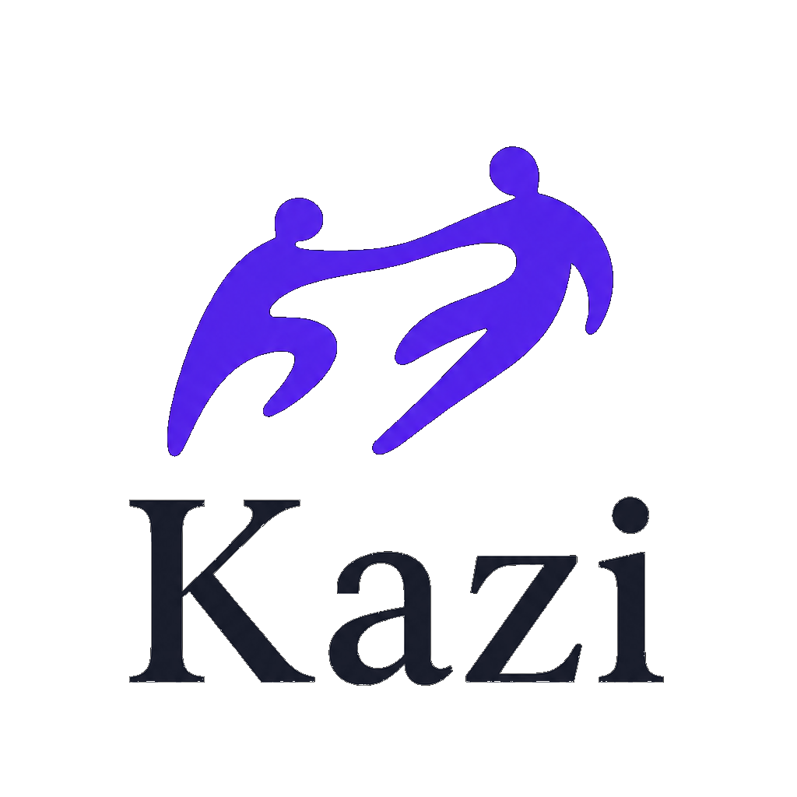
FACT SHEET · 2026
KAZI is the AI work ecosystem that runs your entire business.
One integrated place for projects, clients, proposals, contracts, invoices and payments with escrow, time tracking, files, a client portal and business intelligence. AI is built into every step. Built in South Africa, made for the world.
WHY IT MATTERS
SA freelancers and agencies stitch together dollar-priced tools that can’t take local payments. KAZI is priced in rand with Paystack live and milestone escrow that tackles late payment.
THE GAP
Work tools (ClickUp, Notion, Monday) don’t move money. Money tools (HoneyBook, Bonsai) don’t run the work and don’t serve South Africa. KAZI does both, in one login.
PRODUCT
Projects · CRM · proposals · contracts · invoicing · Paystack payments · escrow · time tracking · files · client portal · calendar · analytics · AI studio (images, video, content, code)
FACTS
Founded by Thabo Nyembe · Kazi Ai (Pty) Ltd, Johannesburg · Free to start, paid from $19/mo · kazii.ai · @getkaziai

